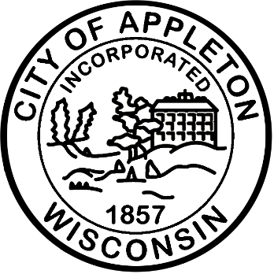

City of Appleton
Operator I - DPW

Come join the City of Appleton and thrive! Here at the City, you’ll have the opportunity to work in a forward-thinking, positive environment alongside other caring team members. You’ll be challenged by rewarding work that impacts the lives of community members each day. You’ll expand your skills and knowledge through training and growth opportunities. You’ll be respected and appreciated for sharing your ideas and bringing your authentic self to your work. And you can celebrate your successes with your loved ones because of the great flexible work arrangements the City offers. Come join our team—you belong here!

The City of Appleton is currently accepting applications for a vacancy in Public Works. Applicants should have experience in equipment operation, refuse collection and snow plowing operations. Work will include general labor in all areas of Public Works including construction, garbage collection, equipment operation, forestry, snow & ice control, and maintenance of utilities. Applicants must have the ability to deal effectively with the public.

Qualifications
Employees must live within a twenty-five-mile radius or reasonably be able to respond to an emergency and report within thirty minutes. A commercial driver’s license with air brakes and trailer endorsements along with a good driving record are required. Hours are Monday – Friday 6:30AM – 2:30 PM.

Salary
The hiring salary range for this position is $26.00 – $27.13, with the ability to earn up to $30.63 hourly. Plus, an excellent fringe benefit package including paid time off, health, life, dental, and Wisconsin Retirement System (WRS). The WRS is among the best funded and best managed public pension systems in the country.

Apply Now!
If you are interested in applying for this position, please complete an on-line application at www.appletonwi.gov/careers by no later than Sunday, August 16, 2026, at 11:59PM. Resumes without an application will not be considered.

City of Appleton Human Resources
100 N. Appleton Street, 6th floor
Appleton, WI 54911
Phone: (920) 832-6458
Email: humanresources@appletonwi.gov
Equal Opportunity Employer

